Analyze a Phishing Email Sample

Tools: Email client or saved email file (text), free online header analyzer.
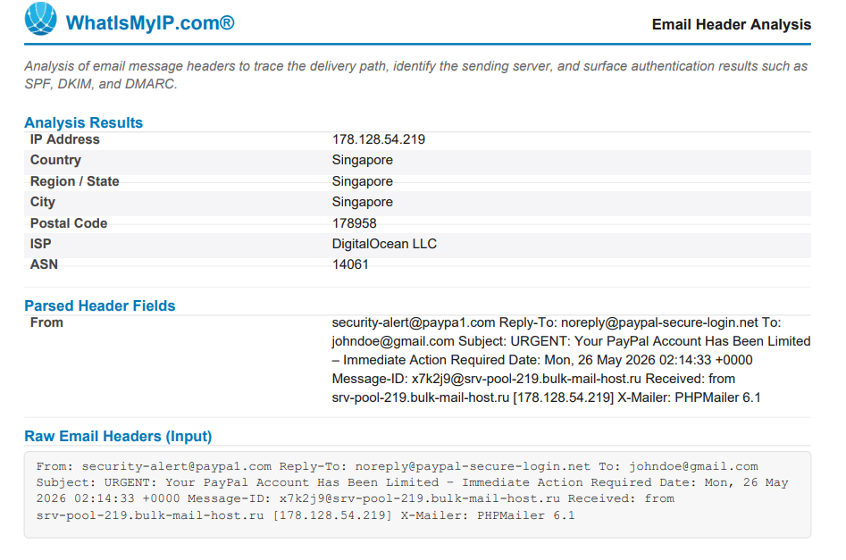

- Obtain a sample phishing email
From: security-alert@paypa1.com Reply-To: noreply@paypal-secure-login.net To: johndoe@gmail.com Subject: URGENT: Your PayPal Account Has Been Limited – Immediate Action Required Date: Mon, 26 May 2026 02:14:33 +0000 Message-ID: x7k2j9@srv-pool-219.bulk-mail-host.ru Received: from srv-pool-219.bulk-mail-host.ru [178.128.54.219] X-Mailer: PHPMailer 6.1

Dear Valued Customer,
We have noticed some suspicious activity on your PayPal account. Your account has been limited due to security reasons. You need to verify your information IMMEDIATELY or your account will be permanently suspended within 24 hours.
Click the link bellow to restore your account access:
>> http://paypal-secure-verify-account.xyz/login?token=xR77QpL <<
You must verify before Monday or you will loose access to your account permanently.
If you did not request this, please ignore this email or contact are support team.
© PayPal Inc. All rights reserved. PayPal, 2211 North First Street, San Jose, CA
- Examine sender's email address for spoofing.
The "From" address in this email is: security-alert@paypa1.com
This is a spoofed address. The real PayPal domain is paypal.com, but this email uses paypa1.com — where the letter "l" has been replaced with the digit "1". This is a typosquatting technique used to trick recipients into thinking the email is from a legitimate source.
Additionally, the "Reply-To" address is: noreply@paypal-secure-login.net
This is a completely different domain from the From address. Legitimate PayPal emails always use @paypal.com for both sending and replies. The mismatch between From and Reply-To is a strong indicator of spoofing.

- Check email headers for discrepancies
Upon analyzing the email headers, the following discrepancies were found:
- Sending Server: The "Received" header shows the email originated from srv-pool-219.bulk-mail-host.ru with IP address 178.128.54.219. The ".ru" domain indicates a Russian server, which has no connection to PayPal's official US-based infrastructure.
- X-Mailer: The header shows "X-Mailer: PHPMailer 6.1". This means the email was sent using a PHP script, which is commonly used in mass phishing and spam campaigns. PayPal uses enterprise-grade email delivery systems, not PHPMailer.
- Message-ID: The Message-ID is: x7k2j9@srv-pool-219.bulk-mail-host.ru The domain in the Message-ID matches the phishing server (bulk-mail-host.ru), further confirming the email did not originate from PayPal's servers.

- Identify suspicious links or attachments.
The email contains the following link: http://paypal-secure-verify-account.xyz/login?token=xR77QpL
This link is suspicious for the following reasons:
-The domain "paypal-secure-verify-account.xyz" is not owned by PayPal Inc. It is a fake domain designed to look legitimate by including the word "paypal" in it.
-The ".xyz" top-level domain is cheap and commonly used in phishing websites due to minimal registration vetting.
-The "?token=xR77QpL" parameter is a unique victim-tracking token. Attackers use this to identify which specific user clicked the link, confirming the email address is active.
-Clicking this link would most likely lead to a fake PayPal login page designed to steal the victim's username and password.
-No legitimate attachments or files were present, but the malicious URL itself serves as the attack vector.

- Look for urgent or threatening language in the email body.
The email contains various high-pressure statements intended to invoke fear and compel the recipient to act without proper consideration:
• SUBJECT: "URGENT: Your PayPal Account Has Been Limited"
• "This limitation has occurred due to security reasons."
• "The verification process has to be done IMMEDIATELY"
• "or your account will be suspended permanently within 24 hours"
• "your access to this account will be permanent"
• "Your verification has to be done before Monday"
This is an example of a standard social engineering strategy. The objective here is to instill a sense of panic and threat of loss in the recipient to bypass their rational thought process and click on the malware-containing link in the email.

- Note any mismatched URLs
The link displayed in the email body appears to direct users to a PayPal verification page. However, the actual destination URL is: http://paypal-secure-verify-account.xyz/login?token=xR77QpL
The domain "paypal-secure-verify-account.xyz" is not PayPal's official domain. Hovering over the link (without clicking) would reveal the true destination, which is a completely different and fraudulent website. This technique — showing one thing but linking to another — is called URL masking and is a very common phishing method.

- Verify presence of spelling or grammar errors.
These spelling and grammar errors were found in the email content:
"Click the link bellow" – should be "below"
"you will loose access" – should be "lose access"
"contact are support team" – should be "contact our support team"
Reputable companies like PayPal ensure professional proofreading of all correspondence to their clients. Multiple simple mistakes can indicate a poorly crafted email created either by someone with limited proficiency in the language or by a scammer bot.

- Summarize phishing traits found in the email.
Phishing indicators found in this particular email are:
-Typosquatted domain name for the sender (paypa1.com vs. paypal.com)
-Different fake domain address used in reply-to field (paypal-secure-login.net)
-Bulk email sent from Russian bulk-mail server (bulk-mail-host.ru) which has nothing to do with PayPal
-PHPMailer, suggesting usage of mass phishing script
-Email originated from the same server where phishers send their emails from (Message-ID)
-Launch of a malicious site that is designed to trick the user into giving away his PayPal account credentials (paypal-secure-verify-account.xyz)
-Token added to the URL to track users who click on that link (?token=xR77QpL)
-Urgency and threats to motivate the user
-Fake link to a malicious website (URL masking)
-Spelling/grammar mistakes (bellow, loose, are support)
CONCLUSION: There is no doubt that this is a phishing email with a high degree of certainty. Phishing takes place via domain spoofing, sending fraudulent emails using sending infrastructure, using deceptive methods and malicious URL to steal user's PayPal account login details.

